**IBM PROJECT**

**ASSIGNMENT-3**

BATCH:8

HARIPRASATH M 1905083

MEERADEVI S 1905094

SANJAI V 190511

THENDRAL S 1905119

**PROGRAM FOR TRAFFIC LIGHT:**

void setup() {

Serial1.begin(9600);

pinMode(21, OUTPUT);

pinMode(20, OUTPUT);

pinMode(19, OUTPUT);

}

void loop() {

digitalWrite(21, HIGH);

delay(3000);

digitalWrite(21, LOW);

digitalWrite(20, HIGH);

delay(3000);

digitalWrite(20, LOW);

digitalWrite(19, HIGH);

delay(3000);

digitalWrite(19, LOW);

}

**OUTPUT:**

**Traffic Lights For Raspberry Pi**

**Blinking Red Light:**

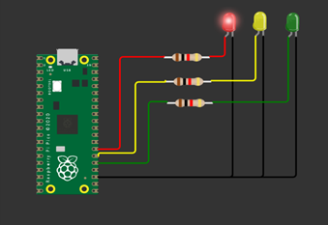

**Blinking Yellow Light:**

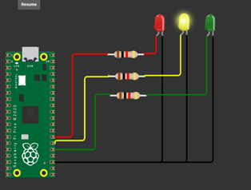

**Blinking Green Light:**

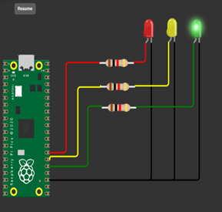

**BLINKING LED:**

**PROGRAM FOR BLINKING LED:**

**Python code:**

void setup() {

Serial.begin(9600);

pinMode(22, OUTPUT);

}

void loop() {

digitalWrite(22, HIGH);

Serial.println("LED ON");

delay(2000);

digitalWrite(22, LOW);

Serial.println("LED OFF");

delay(2000);

}

**Output:**

**Blinking LED For Raspberry pi:**

